# Experiment # 5

Verification of Kirchhoff’s Voltage Law (KVL) using breadboard

# Objective:

To verify Kirchhoff’s Voltage Law (KVL) on breadboard and know relationship between varying resistors and applied voltage.

# Apparatus:

1. Bread board
2. Connecting wires
3. Digital Multimeter
4. Digital Power Supply
5. Different Resistors

# Procedure:

1. First connect the apparatus according to the following circuit diagram:

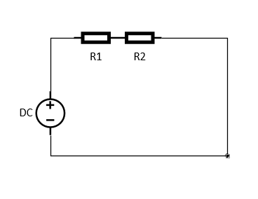

Figure 10 Circuit diagram

1. Find the resistance of the resistors using Digital Multimeter by connecting the knobs of the multimeter across each resistor.
2. Now turn ON the digital power supply and find the voltage drop across each resistor by connecting the knobs of the multimeter across resistor.
3. Repeat the experiment several times for different resistors and voltages.

# Observation:

|  |  |  |  |  |  |  |  |  |
| --- | --- | --- | --- | --- | --- | --- | --- | --- |
| **S.no** | **Vs**  **(actual)**  **(V)** | **R1**  **(Measured)**  **(Ω)** | **R2**  **(Measured)**  **(Ω)** | **V1**  **(Measured)**  **(V)** | **V2**  **(Measured)**  **(V)** | **V1+V2**  **(V)** | **Error** | **Percentage**  **Error**  **(%)** |
| 1. | 5 |  |  |  |  |  |  |  |
| 2. | 10 |  |  |  |  |  |  |  |
| 3. | 15 |  |  |  |  |  |  |  |
| 4. | 20 |  |  |  |  |  |  |  |
| 5. | 30 |  |  |  |  |  |  |  |